Fall 2017 – Outdoor Education Name:
Memory Book Project (Due Tuesday Nov. 7) Date:

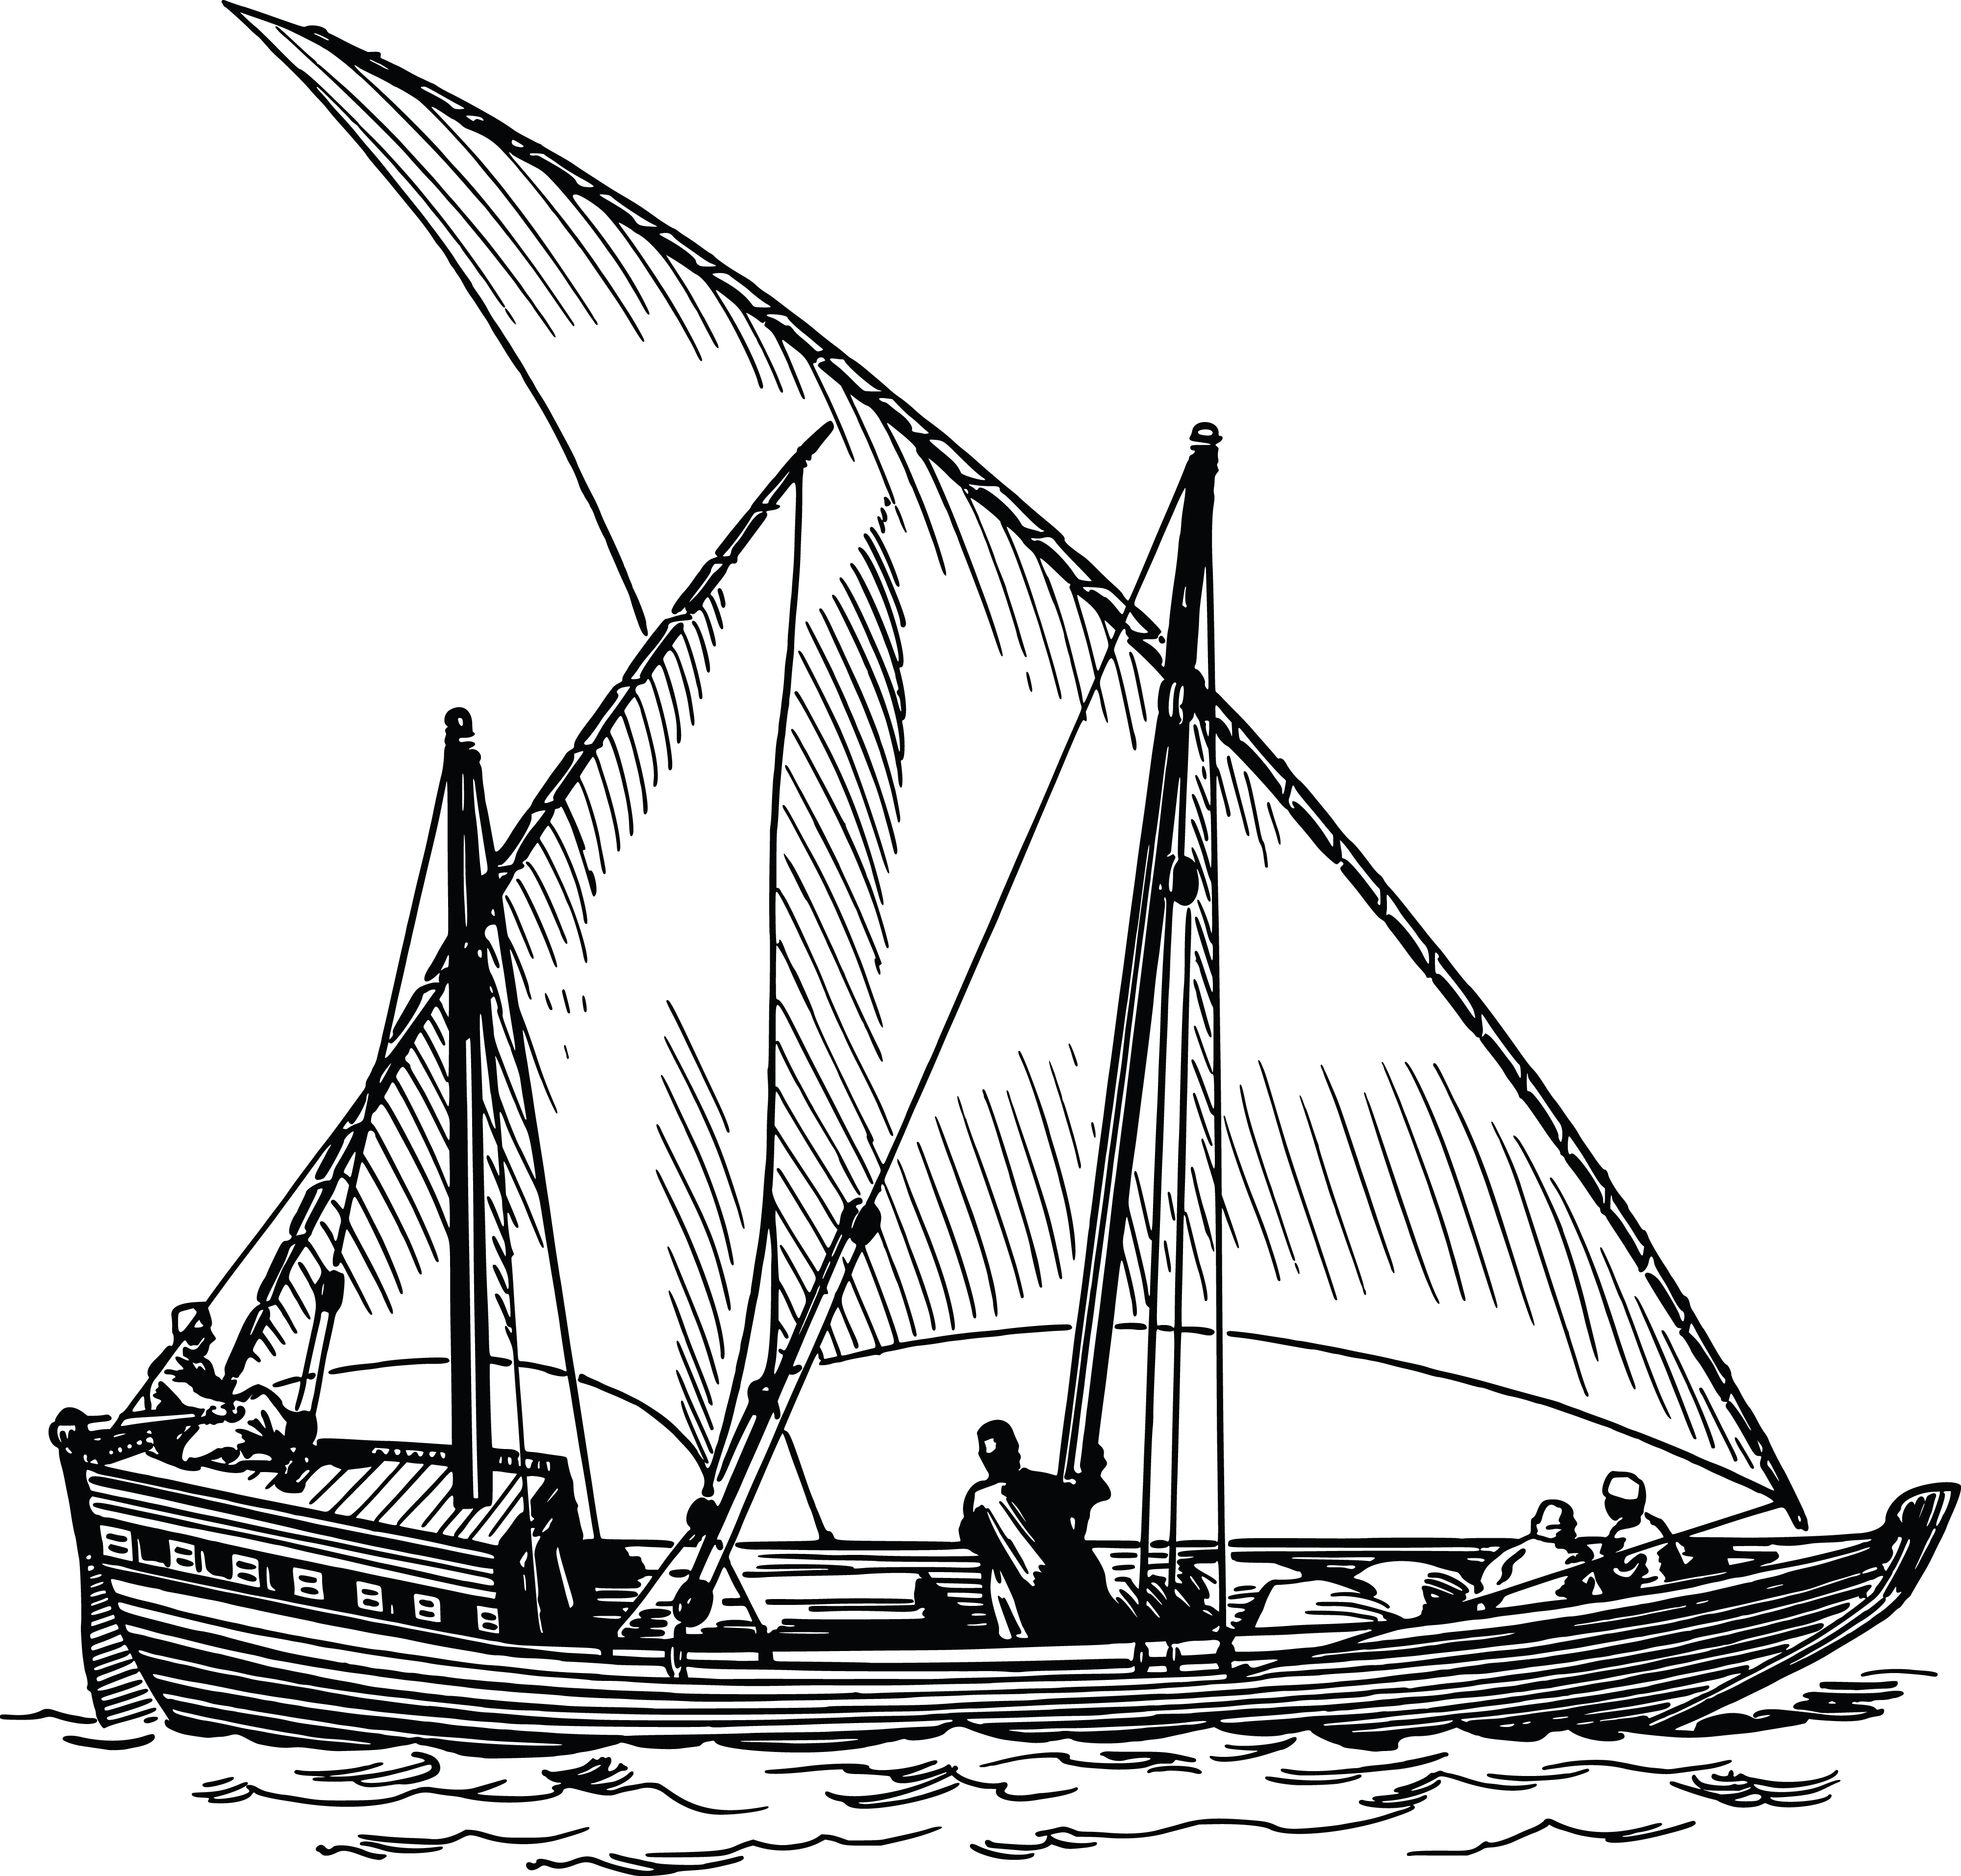
Pick 5 of the writing prompts listed below and answer in paragraph form. You will include 5 pictures in your book, and at least 3 sketch’s. Include a title page as well

- -How this trip changed you…
- -Describe a connection you made on the trip… (person, place, things, activity..etc.)
- What was the most academic thing you learned?
- What was the least academic (most personal) thing you learned
- Describe in detail your favorite place on the trip – Expository writing
- Incorporate one journal entry into your memory book
- Write a poem of a moving experience

Note* - you may purchase your own journal and fill the pages, or you may use regular paper and we will bind it when complete

Fall 2017 – Outdoor Education Name:
Memory Book Project (Due Tuesday Nov. 7) Date:

Pick 5 of the writing prompts listed below and answer in paragraph form. You will include 5 pictures in your book, and at least 3 sketch’s. Include a title page as well

- -How this trip changed you…
- -Describe a connection you made on the trip… (person, place, things, activity..etc.)
- What was the most academic thing you learned?
- What was the least academic (most personal) thing you learned
- Describe in detail your favorite place on the trip – Expository writing
- Incorporate one journal entry into your memory book
- Write a poem of a moving experience

Note* - you may purchase your own journal and fill the pages, or you may use regular paper and we will bind it when complete

